ARJUN N
arjun71196@gmail.com 8138820524
Kozhikode, KL 673616

www.linkedin.com/in
/arjun711/

DIGITAL MARKETING | BRAND STRATEGY | ADVERTISING
HubSpot Inbound Certified Marketer with expertise in brand promotion through innovative ideas, concept design, planning, budgeting, and execution on both paid and organic platforms. Proven ability to ensure brand consistency across campaigns, leverage team management skills, and enhance search engine rankings through strategic SEO and advertising.

SKILLS
Technical Skills

CORE COMPETENCIES
- SEO (Technical, On-Page, Off-Page)

- Google Ads, Google Analytics, Google Tag Manager
- WordPress Management
- Social Media Advertising
- Keyword Research & Strategy
- Social Media Marketing (SMM)
- Google Ads Campaigns (Search & Display)
- Website Traffic Optimization
- Team Management & Leadership

- Content Optimization & Blogging
- SEO Tools (Ahrefs, SEMrush, Moz, etc.)

Soft Skills
- Team Collaboration & Leadership
- Attention to Detail
- Data Analysis & Reporting (Google Analytics, Search Console)

WORK HISTORY

PENTAGON SOLUTIONS - Digital Marketing Executive
Kochi, India • 01/2023 - Current
- Planned and executed web, SEO, database marketing





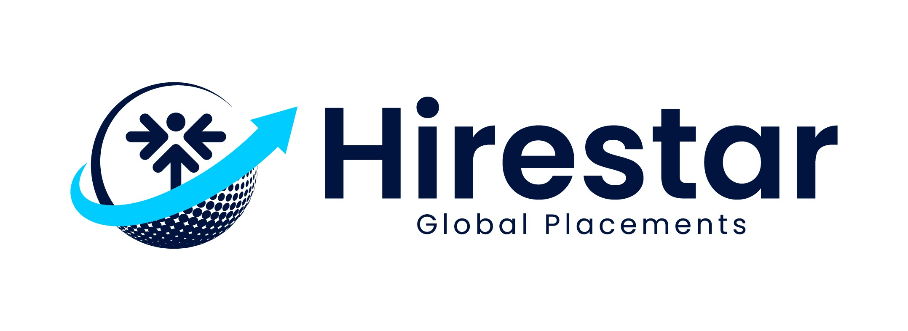
- Problem-Solving & Initiative
- Positive Attitude & Self-Awarenesss

EDUCATION

The Kreative Academy
Kochi, India • 08/2021
Diploma in Digital Marketing:
Digital Marketing

Co-operative College
Kochi, India • 03/2019
Bachelor of Commerce: Finance

Boys' Higher Secondary School
Kochi, India • 03/2016
Plus Two

CERTIFICATIONS
- HubSpot Inbound Marketing Certification
- Directed traffic growth strategies, SEO, content distribution, email marketing, and trackbacks.
- Optimized landing pages for improved conversion rates, utilizing A/B testing and user experience best practices.
- Analyzed web analytics data to identify trends, uncovering opportunities for growth and areas needing improvement.
- Created solution-based execution plans to achieve business goals based on Google Analytics and internal reporting data.
- Increased website traffic by implementing search engine optimization strategies and keyword research.

Skynats Technologies - Digital Marketing Associate
Kochi, India • 07/2021 - 11/2022
- Conducted technical, on-page, and off-page SEO audits to boost website rankings.
- Optimized content based on keyword-specific goals and SEO strategies.
- Analyzed data from tools such as Google Analytics, Search Console, and Google Trends.
- Improved organic search rankings, moving results from 10th to 1st and 2nd positions, with organic user growth from 1,924 to 24,334.
- Managed and executed Google Ads Display Marketing campaigns to target new audiences and drive business growth.Performed keyword analysis, competitor analysis, and on/off-page SEO activities.

- Google Ads Certification
- Google Analytics Certification
- Google Tag Manager Training

  - Built high-quality backlinks to enhance domain authority (DA) and page authority (PA).
  - Conducted website analysis and audits using advanced SEO tools.
  - Oversaw Facebook Ads campaigns, including setup, ad set optimization, and performance tracking.

PROJECTS

SEO
  - Lemax Group – lemaxgcc.com
  - Calix Lighting – calixlighting.co.uk
  - Sitters Child Care Services – sitters.ae
  - EmiratesFire – emiratesfire.ae
  - Hadir Projects – hadirprojects.com
  - Nasco Office Furniture– nasco-uae.com
  - Chartford – chartford.ae
  - CPCON Groups – cpcongroup.ae
  - Al Ain Water – alainwater.com
  - AHS Properties – ahs-properties.com
  - Stallion Printing Press LLC – stallionpressuae.com
  - Reportage – reportageuae.com

Google Ads
  - CPCON Groups – cpcongroup.ae
  - Skynats Technologies - skynats.com

ACCOMPLISHMENTS
  - Achieved top SERP rankings for competitive keywords, driving significant organic traffic growth.
  - Successfully executed paid ad campaigns with measurable ROI improvements.

DECLARATION
I hereby declare that all the information provided above is true to the best of my knowledge and belief.
Arjun N

